**Lesson 3 Demo 5**

**Understanding the Working of Nodes**



Steps to be followed:

1. Verifying the status of a node
2. Deleting a worker node
3. Registering a worker node using a config file

**Step 1: Verifying the status of a node**

1. List all the running nodes in a cluster

***kubectl get nodes***

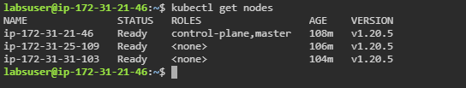

1. Use the following command to verify the status of the worker node:

***kubectl describe node <<nodename>>***

| **Note:** Replace ***<<nodename>>*** with the name of any worker node from Step 1.1 output. In this case we have used second node with the name ***ip-172-31-25-109***. |
| --- |

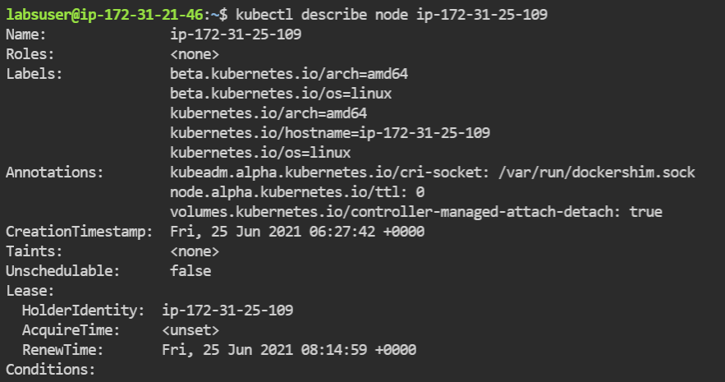

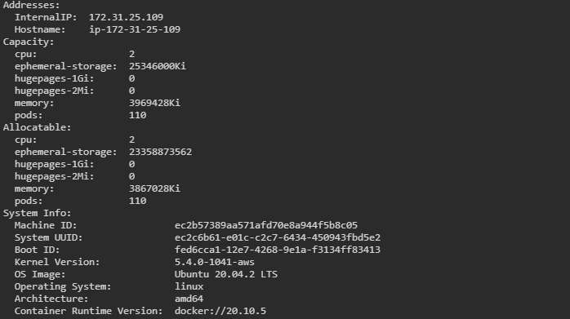

**Step 2: Deleting a worker node**

1. Use the following command to delete a worker node:

***kubectl delete node <<nodename>>***

| **Note:** Replace ***<<nodename>>*** with the name of any worker node from Step 1.1 output. In this case, we have used a second node with the name ***ip-172-31-25-109***. |
| --- |

1. Fetch the list of nodes in the cluster

***kubectl get nodes***

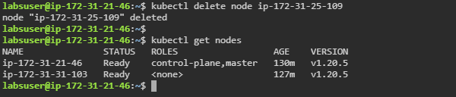

**Step 3: Registering a worker node using a config file**

1. Create a file using the following command:

***vi nodereg.json***



1. Add the following code in the **nodereg.json** file:

***{***

***"kind": "Node",***

***"apiVersion": "v1",***

***"metadata": {***

***"name": "<<nodename>>",***

***"labels": {***

***"name": "firstnode"***

***}***

***}***

***}***

| **Note:** Replace ***<<nodename>>*** with the name of the deleted worker node from **Step 2.1** output. In this case, the node name is ***ip-172-31-25-109***. |
| --- |

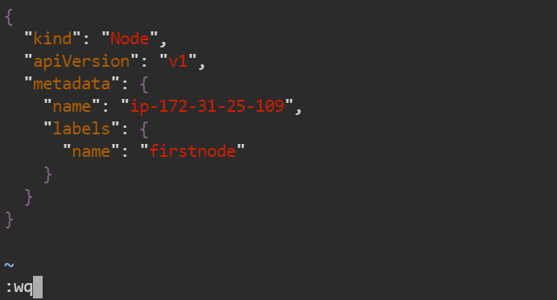

1. Run the following command to register the node using the **nodereg.json** file:

***kubectl create -f ./nodereg.json***



1. Write the following command to verify the created node:

***kubectl get nodes -A***

